Laboratory Goals

- Familiarize students with the National Instruments hardware ELVIS
- Identify the capabilities of ELVIS
- Make use of the built in variable power supply
- Make use of the built in function generator
- Utilize the built in Oscilloscope
- Record results in the laboratory notebook

Pre-lab / lab reading

- ELVIS instruction manual
- Course Textbook

Equipment needed

- Lab notebook, pen
- NI ELVIS

Parts needed

- Jumper wires
- Oscilloscope probes

Lab safety concerns

- Do not make voltage measurements while the multimeter is set for current measurements-you will blow the current limiting fuse!
- Do not turn on the power supply until you have rechecked your circuit for correct wiring
- Do not allow the test leads connected to the power supply to touch each other

1. Lab: Exercise 1.5 – Exercise 2.4

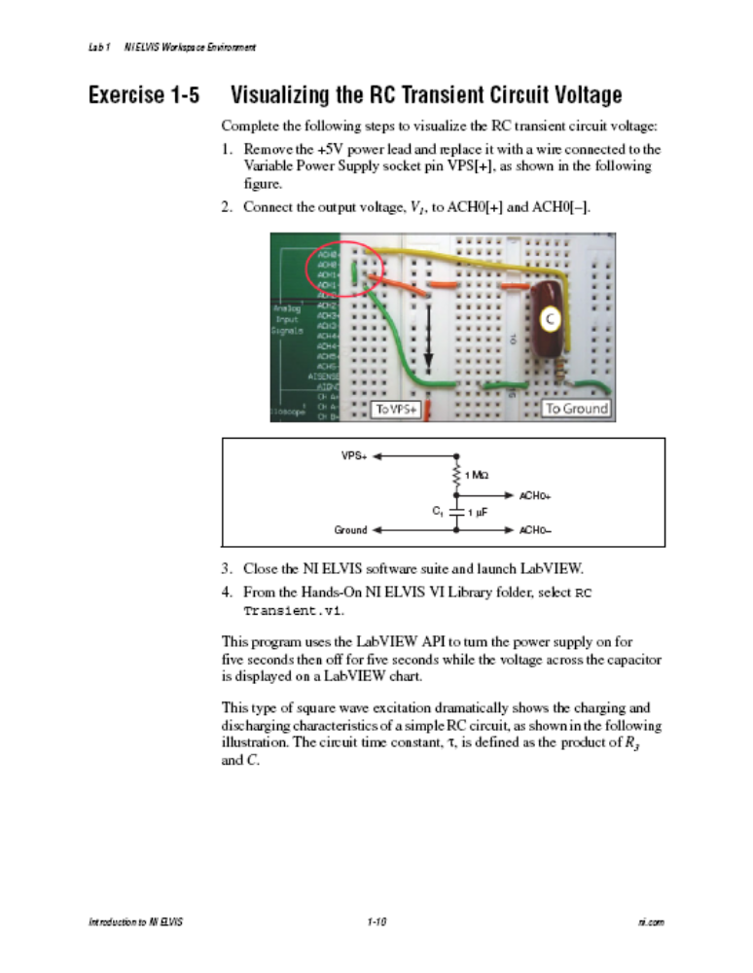

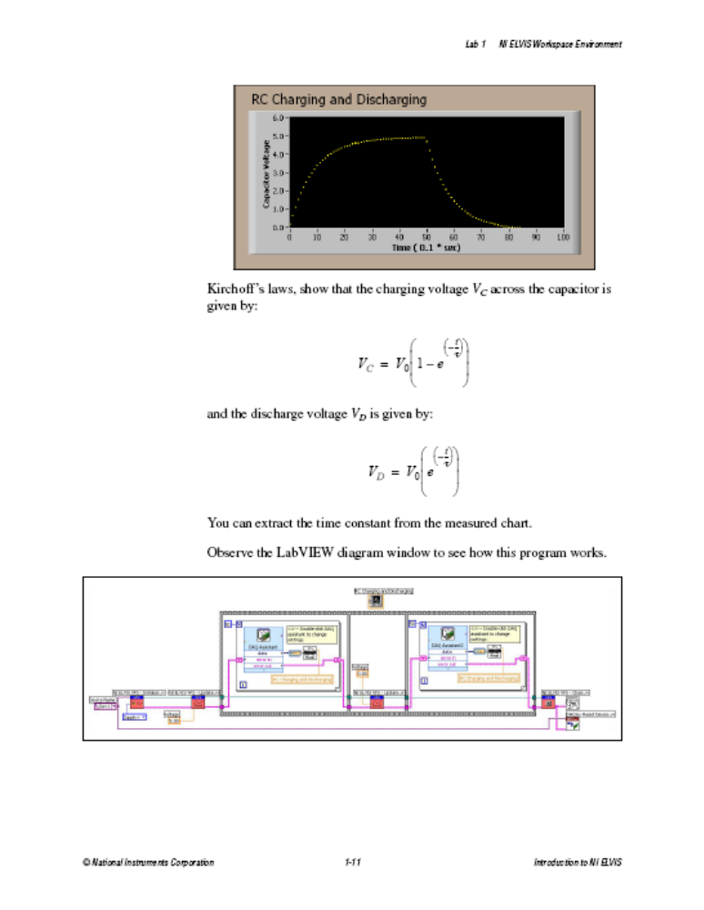
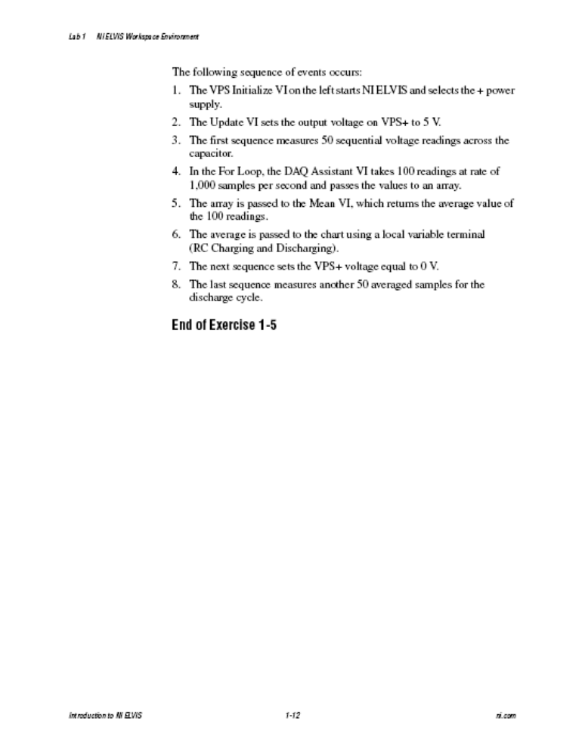

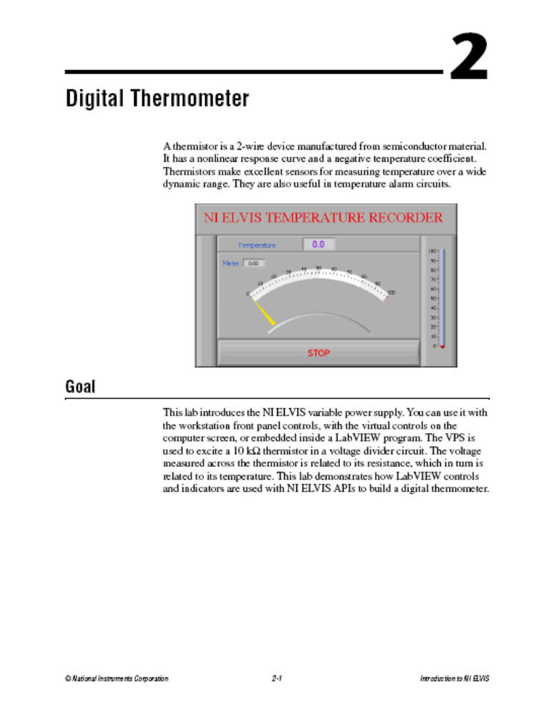
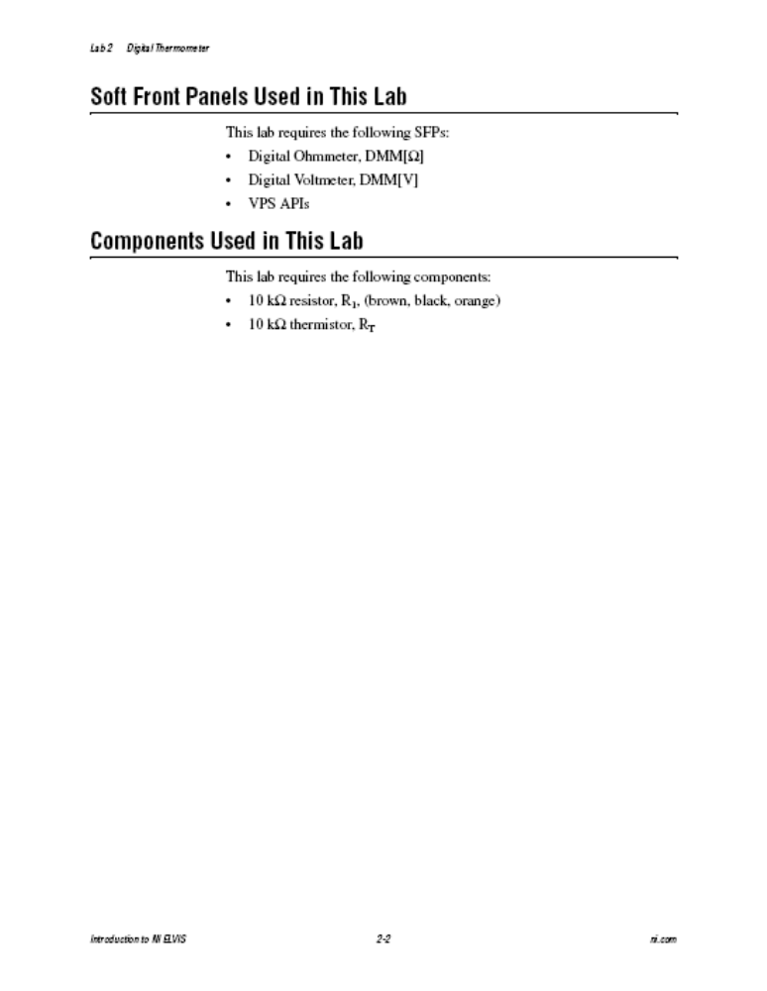
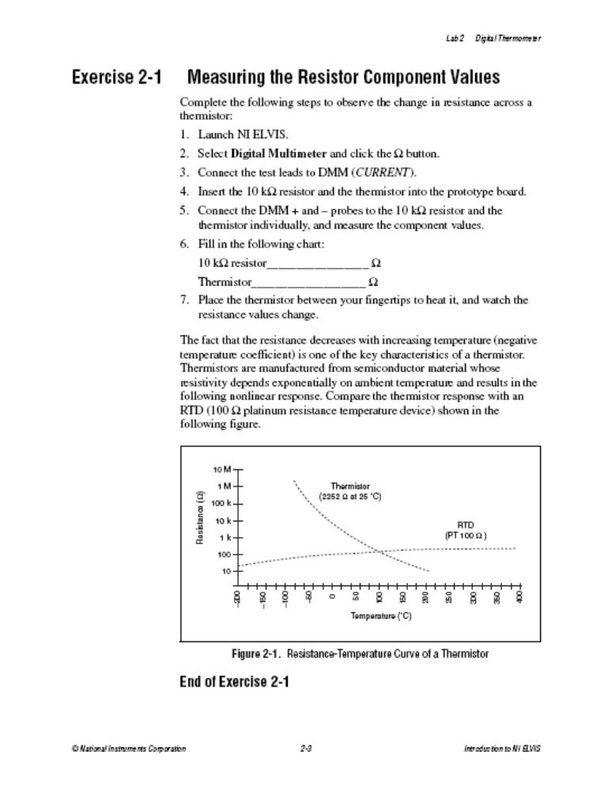
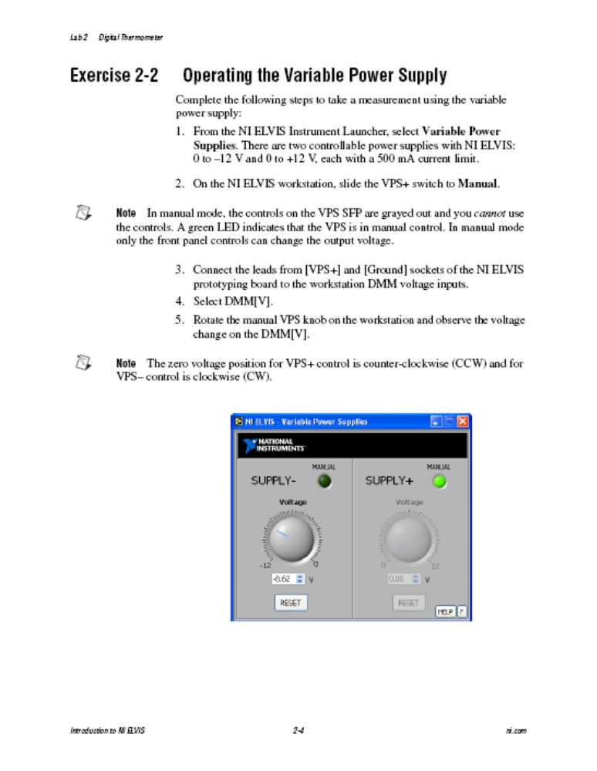
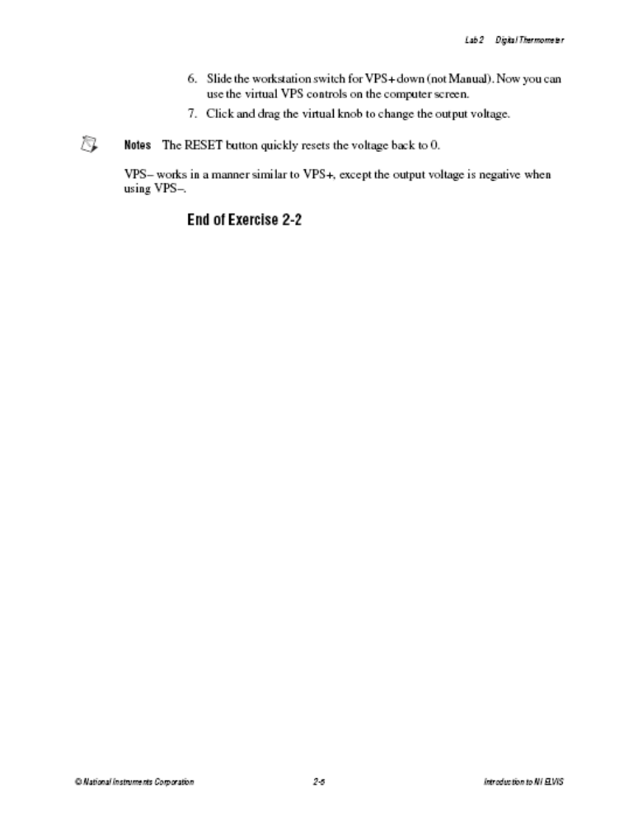
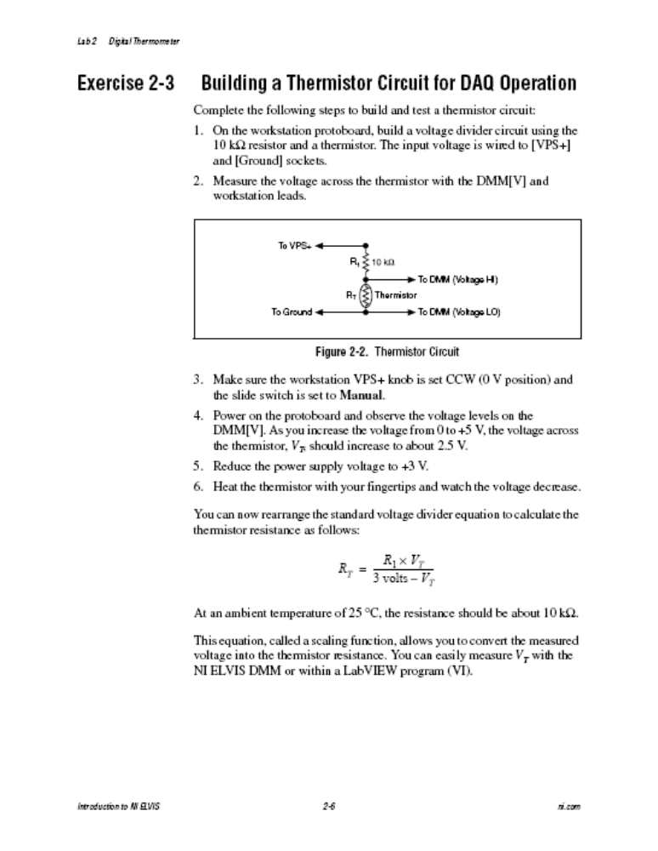
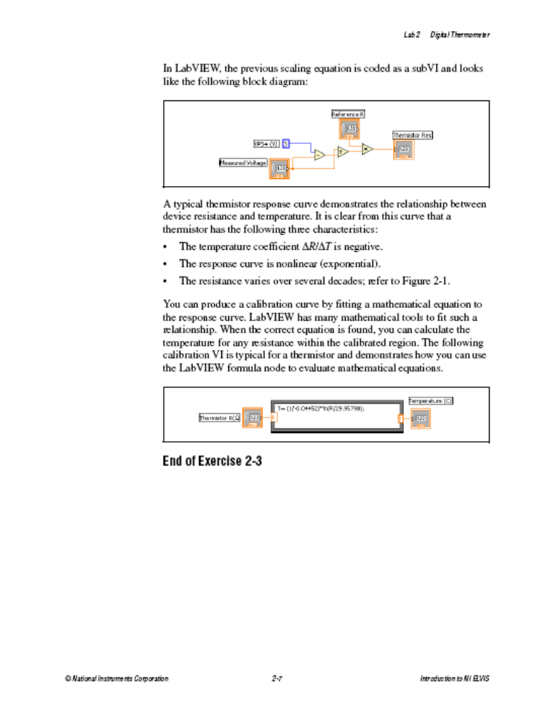
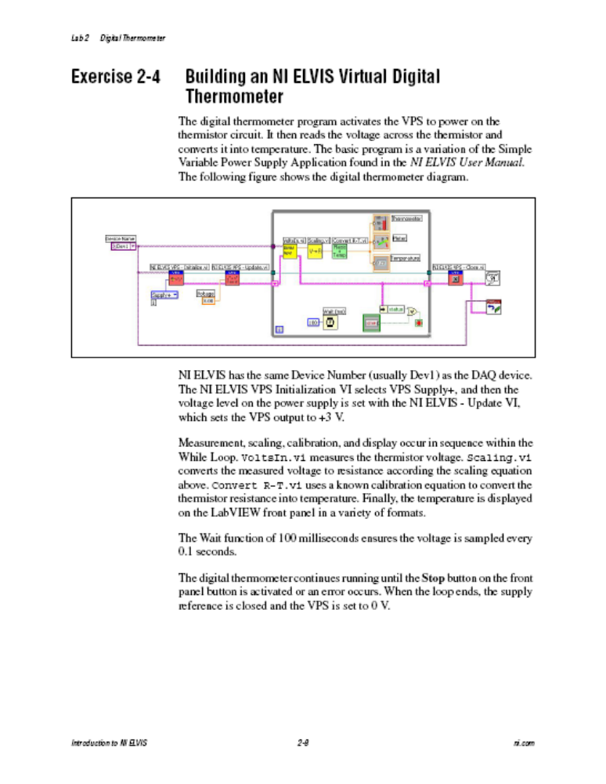
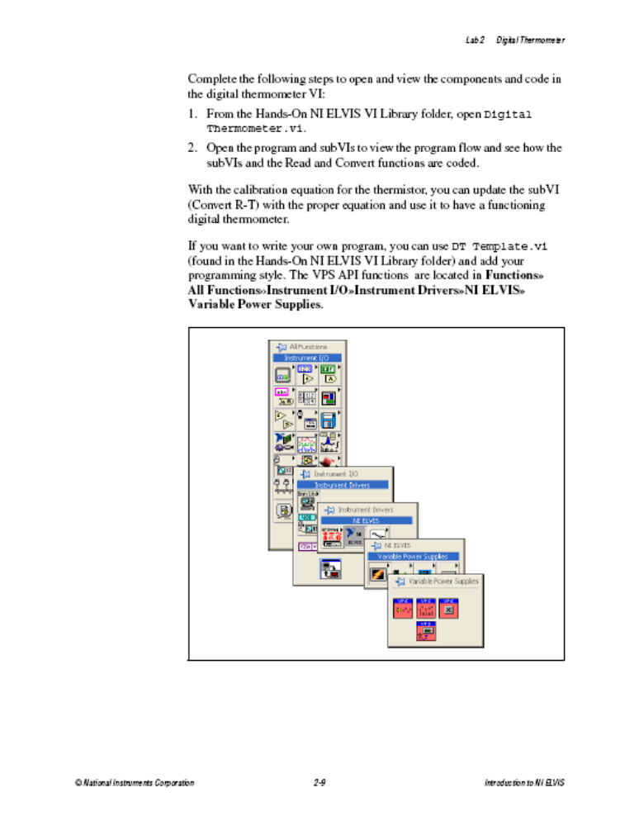
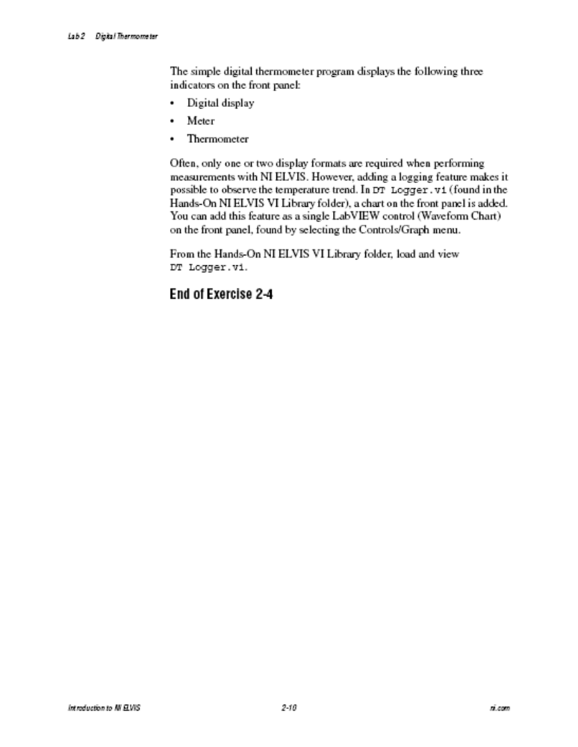

Before leaving the lab, take a few minutes to clean up your workstation, and return all equipment to its place.

